Mike Monostra in The Cherry Hill Sun
- October 2, 2018 - Cherry Hill Planning Board delays vote on 2018 Master Plan - The board voted, 7–2, to continue hearing…
- October 2, 2018 - Cherry Hill Planning Board delays vote on Master Plan - The board opted to delay the vote by one week to…
- October 10, 2018 - After hours of public comment, Cherry Hill Planning Board adopts 2018 Master Plan - The adopted plan includes numerous policies, suggestions and visions to guide Cherry Hill Township’s planning for the next decade.
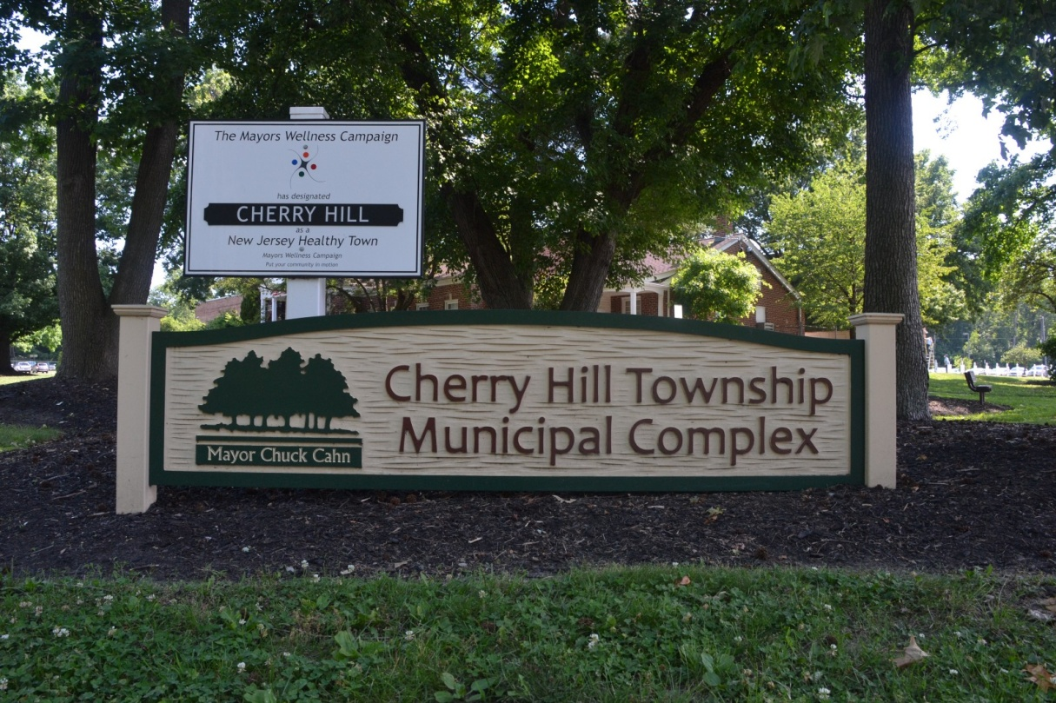
It took about two years of planning, multiple public input sessions and two planning board meetings that lasted more than seven hours combined, but Cherry Hill Township has officially approved its 2018 Master Plan.
Cherry Hill Township Planning Board adopted the Master Plan at its meeting last Monday. Consisting of hundreds of pages, seven chapters and three appendices, township officials describe the plan as a blueprint for how Cherry Hill will move forward with development over the next decade. The plan was approved one week after the planning board opted to extend the public hearing to allow residents more time to read the plan.
The numerous goals of the Master Plan include a balance of “embracing modern land use planning techniques, such as smart growth and transit-oriented development” while also focusing on a balance of commercial and residential develop and “(preserving and enhancing) the cultural, historical and archeological resources that reflect the significant elements of the township.”
Residents express concern with Master Plan comprehensive housing strategy
A little more than 60 residents attended last Monday’s meeting to offer input. Most of the speakers expressed concern with a policy in the land use element of the plan entitled “Implement a comprehensive housing strategy that preserves strong neighborhoods, guides transformation of changing neighborhoods and identifies locations for new residential development.”
The policy listed 16 pre-war and mid-century-dated neighborhoods the plan says “have evolved in response to changes in demographics.” It goes on to say the neighborhoods have experienced an increase in renter populations, increase in multi-generational housing, an increase in the number of non-family members occupying the same house, limited investment in repairs and modernization and more. The 16 listed neighborhoods are Still Park, Hinchman, Woodland, Kenilworth, Barlow, Delwood, Ashland, Ashland Village, Batesville, Kingston Estates, North Erlton, Windsor Park, Knollwood, Cherry Hill Estates, Cooper Park Village and Kingsway Village.
Residents from some of the neighborhoods spoke against two possible items in the plan. One suggests the possibility of designating neighborhoods as areas in need of rehabilitation. The other item calls for the township to look at possibly alternative multi-unit development types for some neighborhoods.
Adam Tecza, senior planner for the township’s planner, Group Melvin Design, said the items weren’t meant to be a negative about the neighborhoods, but instead have a positive impact by providing ideas for how to strengthen the areas in the future.
“These are neighborhoods of change,” Tecza said. “In the contrary of talking about these neighborhoods in a negative way, we’re actually talking about these neighborhoods in a positive light.”
Tecza said the suggestion of declaring neighborhoods in need of rehabilitation was added to give incentives residents to improve their properties. The Master Plan states a rehabilitation designation would “provide tax abatements for improvements that increase value more than $25,000.” Tecza noted two municipalities in New Jersey, Highland Park and Bloomfield, have declared their entire towns areas in need of rehabilitation to take advantage of the benefits.
Tecza said the multi-unit development suggestion was added so the township could consider permitting small, additional units that could be added on to existing homes in some neighborhoods. The plan suggests “context-sensitive multi-unit development” that would look and feel “very similar to single-family homes.”
“We’re not recommending apartment complexes in single-family homes,” Tecza said. “That wasn’t what was shown in the Master Plan. There was no statement of that fact in the Master Plan.”
Despite this explanation, many residents, including some representatives from local civic associations, requested the neighborhoods be removed from the plan. Many of the residents said, despite the intention of the rehabilitation label, they were concerned it would hurt home values.
“We feel (rehabilitation) labels these neighborhoods as the worst in Cherry Hill,” said Dawn Higgins, a representative from the Council of Cherry Hill Civic Associations.
Higgins also suggested the township explore permitting owner-occupied mother-in-law suites in place of some of the other multi-unit suggestions in the plan.
Kingston Estates resident Anne Einhorn said there are a lot of positive aspects about the plan, but noted her neighborhood was one of the 16 listed, leaving her “disheartened.”
“Regardless of what you tell me, the word rehabilitation, whether it’s your words or the state’s words, strikes fear in the heart of many,” Einhorn said.
After some discussion, the planning board unanimously voted to adopt the Master Plan with the listed neighborhoods included.
“I heard what the residents all had the say,” planning board member and Councilwoman Carolyn Jacobs said prior to the vote. “(The rehab designation) sounds like a bad thing. In reality, it’s a really good thing.”
Plans for Place provides vision for seven areas in Cherry Hill
One new addition to this Master Plan is a chapter entitled Plans for Place. This section focuses on seven areas in the township and details a potential vision for what the area might become in the future. The seven locations are the Erlton Village commercial area along Route 70, the Batesville triangle spanning Brace, Kresson and Haddonfield-Berlin roads, the Golden Triangle encompassing the former Garden State Park racetrack and nearby shopping centers and neighborhoods, the Cherry Hill Mall area, the Kings Highway office area, Route 70 East between Springdale Road and the Evesham Township border, and the Springdale Road industrial zone.
Township Director of Community Development Lorissa Luciani said residents identified those seven areas as ones where they would like to see change during the public input process. The Master Plan also states the areas are “facing pressure to change” and “demonstrate policies applied to a variety of land uses.”
“There are areas that came out of the public outreach process where people kind of wanted the township to kind of focus some planning efforts on, just because they haven’t evolved over time,” Luciani said.
Cherry Hill Chief of Staff Erin Gill noted none of the Plans for Place visions are official proposals, but instead gives ideas for possible uses within those areas. The introduction to the Plans for Place section of the plan states, “Seven places within Cherry Hill have been selected as focus areas to illustrate the implementation of the policies and action recommendations within the Land Use and Economic Development Elements as well as how to realize all of the goals of the Master Plan.”
One of the seven areas caught the attention of a few residents. The Kings Highway office area includes a vision for a new municipal complex. The vision would place the municipal complex at the current location of 1040 N. Kings Highway, located next door to the Cherry Hill Public Library. The vision would connect the complex to the library.
In 2016, residents protested talk of the township’s municipal building moving to 1101 and 1103 Kings Highway North, roughly across the street from the library.
A few residents felt the vision plan for the Kings Highway area was very specific and tailored for the possibility of the municipal complex moving from its current location on Mercer Street.
“I was just very concerned that it seemed like an awfully detailed drawing with explicit buildings named in the plan for something that’s not even being considered right now,” resident Patty Magnus said.
Gill said the township has no current plans in place to move Town Hall and noted there would be a long and detailed process if the township were to consider rehabilitating or relocating the municipal complex.
Gill added Kings Highway vision as well as all of the other goals in the Master Plan wouldn’t necessarily be implemented. She instead described the Master Plan as a “road map.”
“Not all of these are necessarily policies or goals that will be implemented,” Gill said. “They are just based on the data.”
There are a few areas of focus in the 2018 Master Plan that can be seen within the Plans for Place. One focus area is to increase the number of pedestrian friendly areas within Cherry Hill.
“It’s about connecting adjoining neighborhoods to certain commercial amenities,” Luciani said. “Trying to contrive a Haddonfield or Collingswood is very difficult in suburbia. Retrofitting suburbia is one of the toughest transformations, especially in a town this large.”
The Master Plan also envisions taking better advantage of mass transit opportunities. The Golden Triangle vision focuses on making development around the NJ Transit train station more transit-oriented and proposes redefining changing the zoning to allow for mixed-use development. Gill said the Springdale industrial vision could also make better use of mass transit through the NJ Transit bus lines running through the area.
Luciani noted all of the Plans for Place visions are in areas with existing development. Gill added a lot of the plan focuses on re-imagining or re-vitalizing existing areas of development to make them more relevant for the township’s changing demographics.
Township officials noted the Master Plan is not a legislative document and for any policies to be implemented, Cherry Hill Township Council would need to take action through the approval of ordinances. In addition, Gill said the township would solicit plenty of public input if the township were to move ahead with any of the vision plans within the Master Plan.
To read the full 2018 Cherry Hill Master Plan, visit www.cherryhill-nj.com/868/Plan-Cherry-Hill.

Mike Monostra

The Cherry Hill Sun
The Cherry Hill Sun is the source for all things Cherry Hill.

