Two years not enough time for Cherry Hill proposed master plan
Jim Walsh, Cherry Hill Courier-Post Published 4:28 a.m. ET Oct. 2, 2018 | Updated 7:33 p.m. ET Oct. 9, 2018
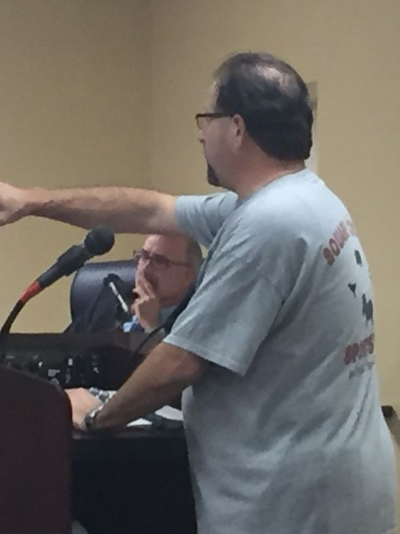
(Photo: Jim Walsh, Staff photographer)
UPDATE: Cherry Hill's planning board adopted the proposed master plan by a unanimous vote at its Oct. 8 meeting.
CHERRY HILL – A proposed master plan, crafted over the past two years, will have to wait another week for an official verdict.
Planning board members on Monday night delayed a vote on adopting the plan after representatives of several civic groups requested more time to read the almost-500-page document.
The board now is to act on the document at a special meeting Oct. 8.
The proposal has been available since Sept. 20 at the municipal building and on the township’s website.
But several speakers, including some who took part in the lengthy planning process, said they only learned of its completion over the weekend.
“Give us more time,” asked Greg Bruno of the Erlton North Civic Association, who said residents want to know more about the document.
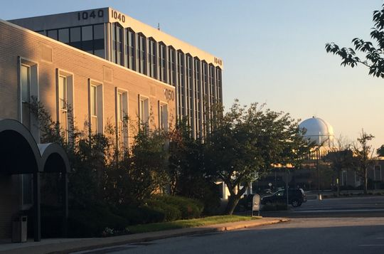
An office park off North Kings Highway could become the new site of a township municipal complex. (Photo: Jim Walsh, Staff photographer)

“They’re very nervous about what this is going to involve,” said Bruno. “They believe that you’re ramming it through for unknown reasons.”
“At this point, you’re going to lose a bit of confidence in the community if you don’t table it,” said Dawn Higgins, a member of the Council of Cherry Hill Civic Associations.
Board attorney James Burns initially argued against a delay, praising the effort to involve residents in the plan’s development as “very significant.”
“Nothing you saw tonight is that earth-shattering,” the board attorney said after a two-hour presentation on the plan's first update since 2007. “We need to move this forward.”
An exchange between Burns and resident Andrew Behrend turned contentious when Burns noted the board's actions had followed the law.
“Why don’t you do it the human being way?” asked Behrend.
And when Behrend complained the document was too lengthy to read over a weekend, Burns pointed out, “There are a lot of pictures in it.”
Board members John Osorio and Marlyn Kalitan voted against the delay.
"At some point, it has to end," said Osorio, the board's chairman.
Lorissa Luciani, the township’s director of community development, noted the master plan itself would not initiate any changes. She said the planning board and township council would have to take action at public meetings to implement any of its recommendations.
Some suggestions that sparked public attention, like moving the town hall to a Kings Highway office park or allowing multi-unit development in residential neighborhoods, are only “food for thought,” said Bob Melvin, a planner whose firm, Group Melvin Design, played a key role in the master plan’s development.
“These are not ready for prime time,” he said.
“We’re looking at it as a possible area to explore,” Melvin added of the potential relocation of township offices. “Sooner or later, the community is going to have to think about its municipal building."

